Beginner Fireball ~ Winter Session 3
Fireball is a new, innovative way to keep your life active and very social! New players, players coming back into the game, senior players, and the most FUN players, are the focus of this light instructional/play league. A slightly slower ball, decompression orange ball, or the green ball (the “Fireball”) are used to play doubles in a very social game. This instructional/play program will cover basic strokes and general positioning. Whether you just graduated from the Instant Rally class, or you are just getting back into the game, this light instructional/play program is for you!
We will provide one hour of instruction during the week, and a match play evening, all for a special reduced price! If you bring a friend (the most fun friend you have), you receive a discount!*

Fireball Tennis: ALL FUN, ALL SOCIAL, ALL TENNIS!
Instruction: 7 week Session: January 7 – February 24
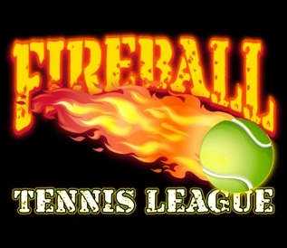
Tuesday 5:00 - 6:00 pm
Thursday 11:00 am - 12:00 pm
Saturday 8:30 - 9:30 am
Match Play Evenings: Friday 6:00 - 7:30 pm
Cost per day: $112.00 for one 7 week session
Drop in: $18.00 per class (space permitting)

Spaces are limited. Register Early! www.chestnutforks.com

